OSMO information

Osmo is a unique gaming accessory that will change the way your child plays. Osmo is designed with reflective artificial intelligence.
The suite of Osmo games include apps that feature drawing, literacy, physics puzzles, spatial reasoning, coding, and more. Each one offers an "augmented reality" experience where the iPad apps bring real-world accessories to life.
The basic Osmo system contains a base for the iPad to sit in and a reflective mirror that attaches to the iPad camera. The reflector adjusts the optics so that the camera is essentially recording the table area in front of the iPad, which enables the Osmo apps can "see" the objects placed there.
1  Put your device in the appropriate Osmo base | 2  Place the red reflector over your device’s front camera. | 3  Objects in front of the base are seen! No batteries required.

OSMO Apps you’ll need to install
Masterpiece, Tangram, OSMO Coding, Numbers, Words and Osmo Coding Awbie,

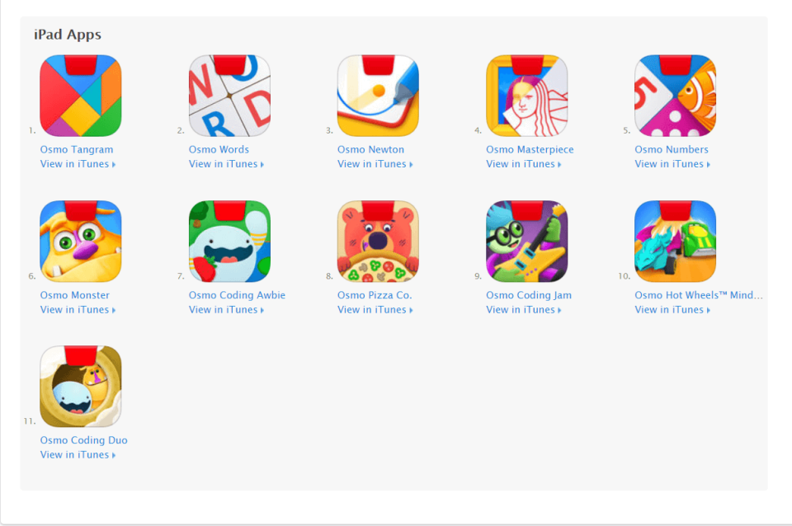
You can find more info at playosmo.com

