Sphero and Mini Sphero Information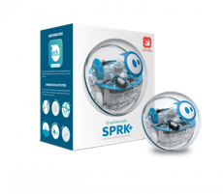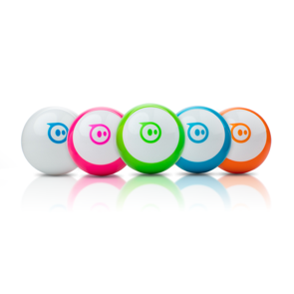

Large spheros – Sphero Spark- uses Sphero app

Equipped with Bluetooth SMART and a scratch-resistant, durable shell, SPRK+ takes hands-on learning up a notch. Programmable sensors like motor encoders, LED lights, accelerometer, and a gyroscope allow for countless experiences and coding conditions. SPRK+ will foster a love of robotics, coding, and STEAM principles… all through play.

Mini Sphero- uses Sphero Edu app
Sphero Edu uses app-enabled robots to foster creativity through discovery and play, all while laying the foundation for computer science. Our program goes beyond code with collaborative STEAM activities, nurturing students’ imaginations in ways no other education program can. Cross-platform apps are approachable for all skill levels, allowing us to reach as many minds as possible.

The Sphero Edu app empowers anyone to program their robot. Drag and drop actions, controls, operators, and more to give your bot the orders.

Ideas for Librarians

Program a maze, draw out the solar system, have a dance party,
Practice coding and using measurement
Tape a design and see who can code the sphero to match it most closely
Use the bowling pins and have a game with a partner
Find activities on the sphero edu website and connect with others around the world.

